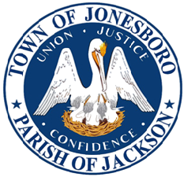
Notice of Public Meeting

Board of Alderman Meeting
Date: October 14, 2025 Time: 6:00pm
Town of Jonesboro
128 Allen Avenue, Jonesboro, LA 7l251
Phone : 318-259-2385 Fax : 318-259-4177

Public Hearing 5:30 p.m.
Questions and Concerns Pertaining to Ordinance 2025-011
Mayor James "Spike" Harris
AGENDA
- Call to Order
- Roll Call
- Invocation
- Pledge of Allegiance
- Public Comments
- Approval of Agenda
- Approval of Minutes
  - September 9, 2025 (Regular Meeting)
  - September 30, 2025 (Special Call Meeting)
- Approval of Financials for August 2025
- To Adopt Resolution 2025-13 Declaring the Intention to Issue Taxable Sewer Revenue Bond
- To Amend an Ordinance (2025-010) to Repeal and Amend Section 20-55 of Jonesboro’s Noxious Grass Ordinance
- To Adopt Surplus Property Ordinance 2025-011 for Fourth Street
- To Introduce an Ordinance 2025-012 Approving DEQ & Water Sector Project
- To Introduce an Ordinance 2025-013 for Utility Rate Increase
- To Discuss the Family Services Kinship Program with Kreesha Bennett
- To Discuss Condemnation of Properties
  - To Vote on Parcel #00950006482 (Beech Springs Road)
  - To Vote on 119 Harlan Street
- Department Head Reports
  - Police Department
  - Compliance
  - Public Works
  - Fire Department
- Approval of Department Head Reports
- Alderman Comments
- Mayor's Comments
- Adjournment

If you need Americans with Disabilities Act (ADA) accommodations, please inform Town Hall prior to the meeting to make necessary arrangements.
Posted By: Date: Time:

